**K8S Version**

<https://github.com/kubernetes/kubernetes/releases>

<https://github.com/kubernetes/community/blob/master/contributors/design-proposals/release/versioning.md>

<https://github.com/kubernetes/community/blob/master/contributors/design-proposals/api-machinery/api-group.md>

<https://blog.risingstack.com/the-history-of-kubernetes/>

<https://kubernetes.io/docs/setup/version-skew-policy>

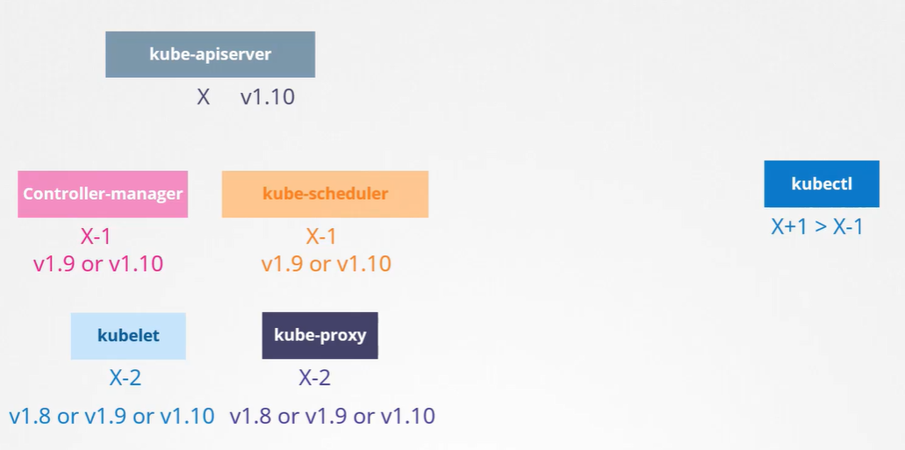

版本升级策略(每次只能升级一个小版本)：

1. Master Node 单独升级，Worker Node 全部统一升级
2. Master Node 单独升级，Worker Node one by one 升级
3. Master Node 单独升级，向集群中添加一台最新版本的Worker Node, 将负载迁移至最新版本的worker node，将旧版本worker node 从节点中删除

https://kubernetes.io/docs/tasks/administer-cluster/kubeadm/kubeadm-upgrade/

Kubeadm 升级步骤

Master Node

1. Kubeadm upgrade plan

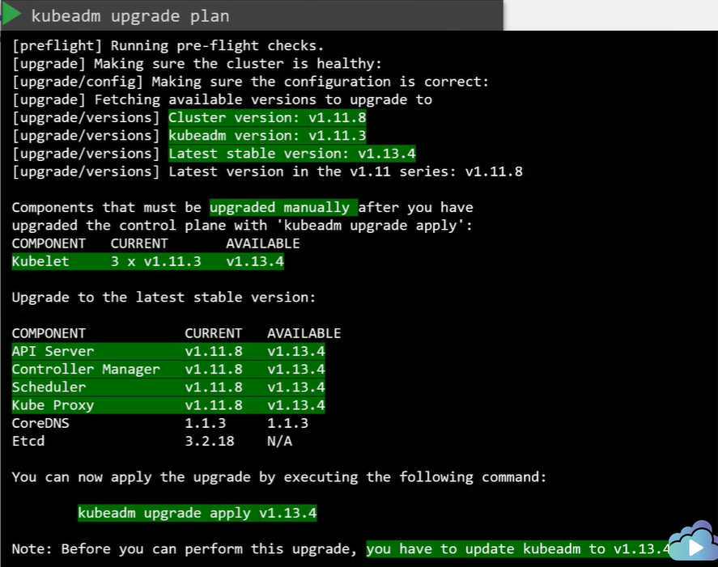

1. Upgrade kubeadm

apt-get upgrade –y kubeadm=1.xx.xx

1. Upgrade Cluster

kubeadm upgrade apply v1.xx.xx

1. Upgrade kubelet

apt-get upgrade –y kubelet=1.xx.xx

systemctl restart kubelet

Worker Node

1. Remove the workerloads

kubectl drain node-1

1. Upgrade the kubeadm
2. Upgrade kubelet
3. Update the node config

kubeadm upgrade node config –kubelet-version v1.xx.xx

systemctl restart kubelet

1. Uncordon Node

kubectl uncordon node